

**RAMAIAH INSTITUTE OF TECHNOLOGY, BANGALORE – 560054**

**(Autonomous Institute, Affiliated to VTU)**

**Department of Computer Science & Engineering**

**Internship Report**

**On**

Frontend Web Development

INT411: Intra Institutional Internship

**STUDENT NAME : BEERAM NIKITA**

**USN : 1MS21CI011**

**Ramaiah Institute of Technology**

**(Autonomous Institute, Affiliated to VTU)**

**MSR Nagar, MSRIT Post, Bangalore-560054**

**September – October, 2022**



**RAMAIAH INSTITUTE OF TECHNOLOGY, BANGALORE – 560054**

**(Autonomous Institute, Affiliated to VTU)**

**Department of Computer Science & Engineering**

**_____________________**

**DEPARTMENT OF**

**CERTIFICATE**

This is to certify that Mr./Ms. ______________________________________________________, a student of Bachelor of Engineering, bearing USN: ______________________, has successfully completed, 30 Hours: from 29.09.2022 to 15.10.2022 Intra Institutional Internship in Frontend Web Development from the Department of Computer Science & Engineering, M S Ramaiah Institute of Technology, Bangalore.

|  |  |  |  |
| --- | --- | --- | --- |
| **SL**  **No.** | **Component** | **Maximum Marks** | **Marks Obtained** |
| **1** | **Continuous Evaluation** | **50** |  |
| **2** | **Presentation** | **20** |  |
| **3** | **Report** | **30** |  |
| **Total Marks** | | **100** |  |

|  |  |
| --- | --- |
| **Signature of the Student with Date** | **Signature of the Faculty Co-Ordinator** |
| **Signature of Head of the Department** | |

**OVERVIEW OF INTERNSHIP ACTIVITIES**

|  |  |  |
| --- | --- | --- |
| **DATE** | **DAY** | **NAME OF THE TOPIC COMPLETED** |
| 29.09.2022 | Thursday | Introduction to Html, Tags and attributes, Linking websites, Linking Images, Headings |
| 30.09.2022 | Friday | Links, Tables, Forms, Email and password, Pattern, Button |
| 06.10.2022 | Thursday | CSS-Introduction, Division and Class Tags, Linking between sections |
| 07.10.2022 | Friday | Style sheet, Class and ID Selectors, |
| 08.10.2022 | Saturday | Pseudo-elements and pseudo-classes, XHTML |
| 10.10.2022 | Monday | Box model, Float, Absolute, Relative, Borders, Font-size |
| 11.10.2022 | Tuesday | JavaScript-Introduction, Steps to write JavaScript, Data types and variables, Operators |
| 12.10.2022 | Wednesday | Functions in JavaScript |
| 13.10.2022 | Thursday | Assessment |
| 14.10.2022 | Friday | Events in JavaScript |
| 15.10.2022 | Saturday | Project execution |

**TABLE OF CONTENTS**

**Contents Page No.**

1. Overall view of the project in terms of implementation
2. Code of main Modules
3. Result Snapshots
4. Conclusion

**OVERALL VIEW OF THE PROJECT IN TERMS OF IMPLEMENTATION**

**HOSTEL SERVICES WEB PAGE**

**-----------------------------------------------------------------------------------------**

OBJECTIVE:

Hostel services web page provides a user friendly interface to access the hostel facilities. The home page consists of information and pictures of the hostel and a login form, where it allows the user to login or if new, it allows the user to register. When login to the home page is done, the user will be directed to the other web page named as menu which offers various options for the user to select according to their need. Each option is linked with their respective web pages which allows the user to enter data and submit. Every web page consists a footer which mentions the contact details of the hostel management and also consist the option to go back and return to the home page which when clicked will redirect to the previous page and home page respectively.

PLAN OF ACTION:

* FORMATTING WEB PAGE LAYOUT USING HTML

All the web pages format is designed using HTML. HTML forms, tables, lists, headings, title, paragraphs, images, fieldset, footer, attributes etc are all included in the web pages. The layout of the web page is built in such a way that the user finds it easy to access and use.

* DESIGNING THE WEB PAGE USING CSS

The web pages are designed using CSS to make it attractive and eye catching to the user. Background colours, background images, font style, font size, font weight, font colour, alignment elements such as text alignment, float, position and display, border style, border width and height along with margin and padding, border colour, border shape which includes border radius are used for the decoration of text in the web pages. Hover attribute is used for the links which allows them to respond to the transition effects when the mouse hovers them.

* INTERACTION OF WEB PAGES USING JAVASCRIPT

JavaScript is used for making the webpages more interactive and dynamic. When the home page is directed to the menu page, a pop-up alert message is displayed on the screen which is created using JavaScript. A confirm alert message appears when a form.is submitted. The slideshow of images in the home page is done by writing the script and navigation of page from bottom to top and to the particular section when clicked is enabled. In the register form, script is written for the confirm password input box such that the value is only accepted when the given data in the password and confirm password input box matches.

**CODE OF MAIN MODULES**

**-----------------------------------------------------------------------------------------**

MODULES :

1. homepage.html
2. rergister.html
3. menu.html
4. mess.html
5. roomservices.html
6. cleaningservices.html
7. laundry.html
8. events.html
9. complaints.html
10. tablestyle.css

**SOURCE CODE :**

1. homepage.html

Code :

<!DOCTYPE html>

<html>

<head>

<meta charset="utf-8">

<title>Home</title>

<style>

.h1{

font-size: 40pt;

font-family: 'Franklin Gothic Medium', 'Arial Narrow', Arial, sans-serif;

text-align: center;}

.h2{

font-size: 30pt;

font-family: 'Franklin Gothic Medium', 'Arial Narrow', Arial, sans-serif;

text-align: center; }

.row{

border: none;

display:inline-block; }

.col{

display:inline-block; }

.icon-center{

border: solid #79B1BF;

border-radius: 100px;

width: 200px;

height: 200px;}

#form{

float: right;

border: 2px solid burlywood;

margin-top: 50px;

padding: 10px; }

.login{

font-size: 20px;

font-family: 'Courier New', Courier, monospace; }

.user{

font-size: 18px;}

* {box-sizing:border-box}

.slideshow-container {

max-width: 1000px;

position: relative;

margin: auto;}

.mySlides {

display: none; }

.dot {

cursor: pointer;

height: 15px;

width: 15px;

margin: 0 2px;

background-color: #bbb;

border-radius: 50%;

display: inline-block;

transition: background-color 0.6s ease; }

.active, .dot:hover {

background-color: #717171; }

.fade {

animation-name: fade;

animation-duration: 1.5s; }

@keyframes fade {

from {opacity: .4}

to {opacity: 1}}

.con{

border: 3px solid;

width: 1250px;

padding-bottom: 1px;

margin-bottom: 1px;

background-color: rgb(79, 90, 50);}

.copy{

border-top: 1px solid;

text-align: center;}

.add{

color: azure;}

.foot1{

text-align:right;

font-weight: bold;}

.button{

border:2px solid;

width:40px;

height:20px;

font-size:10pt;

background-color: blue;}

.button:hover{transform: scale(1.2);}

a{color: black;}

a.regis{color: blue; font-size: 16px;}

a.regis:hover{font-size: 18px;}

</style>

</head>

<body>

<div id="head">

<div class="h1"><img align="center" src="logo.png" alt="logo" width="160" height="160" style="border:none;border-radius:80px;">NIMS GIRLS HOSTEL</div>

<div class="h2">(M.S.R. GOKUL VIDYARTHI NIMS)</div></div>

<div class="slideshow-container">

<div class="mySlides fade"><img src="p1.png" style="width:100%" height="600"></div>

<div class="mySlides fade"><img src="p2.png" style="width:100%" height="600"></div>

<div class="mySlides fade"><img src="p7.png" style="width:100%" height="600"></div>

<div class="mySlides fade"><img src="p3.png" style="width:100%" height="600"></div>

<div class="mySlides fade"><img src="p4.png" style="width:100%" height="600"></div>

<div class="mySlides fade"><img src="p8.png" style="width:100%" height="600"></div>

<div class="mySlides fade"><img src="p11.png" style="width:100%" height="600"></div>

<div class="mySlides fade"><img src="p10.png" style="width:100%" height="600"></div>

<div class="mySlides fade"><img src="p9.png" style="width:100%" height="600"></div> </div><br>

<div style="text-align:center">

<span class="dot" onclick="currentSlide(1)"></span>

<span class="dot" onclick="currentSlide(2)"></span>

<span class="dot" onclick="currentSlide(3)"></span>

<span class="dot" onclick="currentSlide(4)"></span>

<span class="dot" onclick="currentSlide(5)"></span>

<span class="dot" onclick="currentSlide(6)"></span>

<span class="dot" onclick="currentSlide(7)"></span>

<span class="dot" onclick="currentSlide(8)"></span>

<span class="dot" onclick="currentSlide(9)"></span> </div>

<script>

let slideIndex = 0;

showSlides();

function showSlides() {

let i;

let slides = document.getElementsByClassName("mySlides");

for (i = 0; i < slides.length; i++) {

slides[i].style.display = "none";}

slideIndex++;

if (slideIndex > slides.length) {slideIndex = 1}

slides[slideIndex-1].style.display = "block";

setTimeout(showSlides, 2000); }</script>

<div id="hi" style="float :left;">

<div class="row" style="padding-top:20px">

<div class="col">

<img class="icon-center" src="power-Backup1.png"> </div>

<div class="col">

<img class="icon-center" src="security1.png"> </div>

<div class="col">

<img class="icon-center" src="Food1.png"></div>

<div class="col">

<img class="icon-center" src="Laundry-service1.png"></div></div>

<br><br>

<div class="row"> <div class="col">

<img class="icon-center" src="RO1.png"></div>

<div class="col">

<img class="icon-center" src="indoor-game1.png"></div>

<div class="col">

<img class="icon-center" src="House-Keeping1.png"></div>

<div class="col"><img class="icon-center" src="wifi1.png"></div>

</div></div><div id="form">

<p class="login"><strong>LOGIN :</strong></p><br><form>

<div class="user">

<input type="text" name="userid" placeholder="user name" style="width : 400px; height : 30px" required><br><br>

<input type="password" name="password" placeholder="password" style="width : 400px; height : 30px" required><br><br>

<div class="button"> <a href="menu.html" onclick="onOpen()">Login</a>

</div></div><br></div><div class="user">

New? <a href="register.html" class="regis">Register now</a><br>

</div><script type="text/javascript">

function onOpen(){alert("Welcome!!"); }</script></form></div>

<br><br><br><br><fieldset class="con" ><div class="add">

<img src="logo.png" alt="logo" style="float: left;" width="10%" height="10%">

<p style="font-size:16pt;">NIMS GIRLS HOSTEL,</p>

<p style="font-size:15pt;">GOKUL VIDYARTHI NIMS,</p>

<p style="font-size:13pt;">No 2/8, M.S.Ramaiah Engineering College Road,M.S.R.I.T Post,Bangalore-54.</p></div><div class="foot1">

<p style="font-size:15pt;">CONTACT DETAILS:</p>

Mr.Harish Kumar<br>Chief Manager<br>Ph.no: 982****782<br>

Email: harish***@gmail.com<br><br>

Mrs.Kalyani Kathakam<br>Head Manager<br>Ph.no: 894****799<br>

Email: harish***@gmail.com<br><br> Mrs.Sunanda Geetha<br>

Head Warden<br>Ph.no: 857****527<br>

Email: geetha***@gmail.com<br><br></div><br>

<p class="copy">@Copyrights Reserved.</p>

</fieldset></body></html>

1. register.html

<!DOCTYPE html>

<html>

<head>

<meta charset="utf-8">

<title>New user registration</title>

<style>

#h1{

font-size: 40pt;

font-family: cursive;

text-align: center;}

#h2{

font-size: 20pt;

font-family: Verdana, Geneva, Tahoma, sans-serif;

text-align: center;

border: solid #79B1BF;

margin: 10px;

padding-left: 10px;

padding-top: 6px;

padding-right: 10px;

padding-bottom: 6px;}

.name{

border: solid #79B1BF;

font-size: 18px;

margin: 10px;

padding: 10px;

text-align: center;}

.home{text-align: right;}

</style></head>

<body background="bgregister.png">

<div id="h1">Welcome to Gokul!!</div>

<div class="home">Click <a href="homepage.html" >here</a> to return to homepage</div><form>

<div id="h2">Personal details</div><div class="name">

Name*: <input type="text" name="fname" placeholder="First name" required><input type="text" name="sname" placeholder="Last name"><br><br>

Mobile Number*: <input type="text" name="mnum" pattern="[0-9]{10}" required><br><br>Email*: <input type="email" name="email" required><br><br>

Region: <select name="state">

<option value="Andhra Pradesh">Andhra Pradesh</option> <option value="Andaman and Nicobar Islands">Andaman and Nicobar Islands</option> <option value="Arunachal Pradesh">Arunachal Pradesh</option>

<option value="Assam">Assam</option> <option value="Bihar">Bihar</option> <option value="Chandigarh">Chandigarh</option> <option value="Chhattisgarh">Chhattisgarh</option> <option value="Dadar and Nagar Haveli">Dadar and Nagar Haveli</option>

<option value="Daman and Diu">Daman and Diu</option> <option value="Delhi">Delhi</option>

<option value="Lakshadweep">Lakshadweep</option> <option value="Puducherry">Puducherry</option>

<option value="Goa">Goa</option> <option value="Gujarat">Gujarat</option>

<option value="Haryana">Haryana</option> <option value="Himachal Pradesh">Himachal Pradesh</option>

<option value="Jammu and Kashmir">Jammu and Kashmir</option> <option value="Jharkhand">Jharkhand</option> <option value="Karnataka" selected>Karnataka</option> <option value="Kerala">Kerala</option> <option value="Madhya Pradesh">Madhya Pradesh</option>

<option value="Maharashtra">Maharashtra</option>

<option value="Manipur">Manipur</option> <option value="Meghalaya">Meghalaya</option>

<option value="Mizoram">Mizoram</option> <option value="Nagaland">Nagaland</option>

<option value="Odisha">Odisha</option> <option value="Punjab">Punjab</option>

<option value="Rajasthan">Rajasthan</option> <option value="Sikkim">Sikkim</option>

<option value="Tamil Nadu">Tamil Nadu</option> <option value="Telangana">Telangana</option>

<option value="Tripura">Tripura</option> <option value="Uttar Pradesh">Uttar Pradesh</option>

<option value="Uttarakhand">Uttarakhand</option> <option value="West Bengal">West Bengal</option> </select><br><br>

Room Number*:<input type="text" name="rnum" required><br><br>

Building name*:<select name="building" >

<option value="mess building">Mess building</option>

<option value="mess building">Office building</option>

<option value="mess building">Single building</option>

<option value="mess building">X building</option>

</select><br><br></div><div id="h2">Register Details</div>

<div class="name">

User name*: <input type="text" id="user id" required><br><br>

Password*: <input type="password" placeholder="Password" id="password" required><br><br>

Re-enter Password*: <input type="password" placeholder="Confirm Password" id="confirm_password" required><br><br></div>

<input type="submit" value="Submit" onclick="onSub()"><script>

function onSub(){

if(confirm("Are you sure to submit?")){

alert("Return to homepage to login")}

else{

alert("Return to homepage to login")}}</script>

<input type="reset" value="Clear"></form>

<script>var password = document.getElementById("password")

, confirm_password = document.getElementById("confirm_password");

function validatePassword(){

if(password.value != confirm_password.value) {

confirm_password.setCustomValidity("Passwords Don't Match");

} else { confirm_password.setCustomValidity(''); }}

password.onchange = validatePassword;

confirm_password.onkeyup = validatePassword;</script></body></html>

1. menu.html

<!DOCTYPE html>

<html><head>

<meta charset="utf-8">

<title>Menu</title>

<style>

#mbox{ text-align: center; border: none; padding: 5px; margin: 10px; }

.row{ border: none; display:inline-block; }

.col{display:inline-block; text-align: center; font-size: 15pt; }

.icon-center{border: solid black; border-radius: 20px; width: 210px;

height: 210px;padding: 10px; margin: 10px;

font-family: 'Franklin Gothic Medium';}

.head{ text-align:center; font-weight:bold; font-size: 18pt;

font-family: 'Times New Roman', Times, serif;

border:2px solid blueviolet; margin:10px; padding:15px;}

.pic{ border: none; border-radius: 90px;}

.icon-center:hover{transform: scale(1.2);}

.copy{ border-top: 1px solid; text-align: center;}</style></head>

<body background="bgmenu.png">

<p style="font-family: 'Franklin Gothic Medium', 'Arial Narrow', Arial, sans-serif;font-size: 35pt;">NIMS GIRLS HOSTEL</p>

<p style="font-family: 'Franklin Gothic Medium', 'Arial Narrow', Arial, sans-serif;font-size: 20pt;">M.S.R GOKUL VIDYARTHI NIMS</p>

<div class="head">MENU</div><div id="mbox"><div class="row">

<div class="col">

<p class="icon-center">Mess<a href="mess.html"><img class="pic" src="mess.png" width="180px" height="180px"></a></p></div><div class="col">

<p class="icon-center">Room services<a href="roomservices.html"><img class="pic" src="room.png" width="180px" height="180px"></a></p></div>

<div class="col">

<p class="icon-center">Cleaning services<a href="cleaningservices.html"><img class="pic" src="cleaning.png" width="180px" height="180px"></a></p></div>

</div><br><div class="row"><div class="col">

<p class="icon-center">Laundry servives<a href="laundry.html"><img class="pic" src="laundry.png" width="180px" height="180px"></a></p></div><div class="col">

<p class="icon-center">Events<a href="events.html"><img class="pic" src="events.png" width="180px" height="180px"></a></p></div><div class="col">

<p class="icon-center">Complaints<a href="complaints.html"><img class="pic" src="complaint.png" width="180px" height="180px"></a></p></div></div></div>

<br><p style="text-align: right;"><a href="homepage.html">logout</a><p>

</body></html>

1. mess.html

<!DOCTYPE html><html>

<head><meta charset="utf-8">

<title>Mess</title>

<link rel="stylesheet" type="text/css" href="tablestyle.css">

<style>

#h1 { border: 2px ridge rgb(219, 39, 147); padding: 10px; margin: 10px;}

.copy{ border-top: 1px solid; text-align: center;}</style></head>

<body >

<div id="h1"><img align="center" src="food0.png" alt="food" width="140" height="140" style="border-radius:70px ; border: 1px solid black;">MESS SCHEDULE<img align="center" src="food3.png" alt="food" width="140" height="140" style="border-radius:70px ; border: 1px solid black;"></div>

<img align="center" src="p5.png" alt="mess" width="900" style="padding-left: 170px;margin-bottom: 10px;">

<table border="3px" align="center" width="1000" background="bgmess.png" style="background-repeat:no-repeat;">

<tr><th class="h3">Days</th><th class="h3">Food</th>

<td rowspan="22" class="h4"><div style="text-align:center">Daily served foods :</style></div><ul><li>Dal</li><li>Roti</li><li>Curd</li><li>Keera</li><li>Papad</li></ul> </td></tr> <tr >

<td rowspan="3" class="day">Monday</td>

<td class="day"><strong>Tiffin:</strong> Dosa and Idly with chutney </td></tr>

<tr><td class="day"><strong>Lunch:</strong> Rajma curry with Jeera rice </td>

</tr><tr> <td class="day"><strong>Dinner:</strong> Gobi curry with specials(Egg/mirchi bajji)</td></tr><tr>

<td rowspan="3" class="day">Tuesday</td>

<td class="day"><strong>Tiffin:</strong> Aloo Paratha with sauce</td></tr><tr>

<td class="day"><strong>Lunch:</strong> Bottlegaurd curry with Ghee rice </td>

</tr><tr><td class="day"><strong>Dinner: </strong> Puri with Aloo curry</td>

</tr><tr ><td rowspan="3" class="day">Wednesday</td>

<td class="day"><strong>Tiffin:</strong> Utappam with sambhar and chutney </td>

</tr><tr>

<td class="day"><strong>Lunch:</strong> Brinjal curry with rice </td></tr><tr>

<td class="day"><strong>Dinner:</strong> Rice with Chicken curry/Panneer curry </td></tr><tr ><td rowspan="3" class="day">Thursday</td>

<td class="day"><strong>Tiffin:</strong> Gobi Paratha with sauce</td></tr><tr>

<td class="day"><strong>Lunch:</strong> Aloo mathar with rice</td>

</tr><tr><td class="day"><strong>Dinner:</strong> Soya bean with fried rice</td>

</tr><tr><td rowspan="3" class="day">Friday</td>

<td class="day"><strong>Tiffin:</strong> Vada and Idly with sambhar and chutney </td></tr><tr>

<td class="day"><strong>Lunch:</strong> Chana masala with Jeera rice</td></tr>

<tr><td class="day"><strong>Dinner:</strong> Noodles and fried rice with specials(Egg/Gobi Manchurian)</td></tr><tr >

<td rowspan="3" class="day">Saturday</td>

<td><strong>Tiffin:</strong> Onion paratha with sauce</td></tr><tr>

<td class="day"><strong>Lunch:</strong> Kichidi and curd rice</td></tr><tr>

<td class="day"><strong>Dinner:</strong> Chole batora</td></tr><tr >

<td rowspan="3" class="day">Sunday</td>

<td class="day"><strong>Tiffin:</strong> Masala Dosa with chutney</td></tr><tr>

<td class="day"><strong>Lunch:</strong> Chicken/Veg biryani</td></tr><tr>

<td class="day"><strong>Dinner:</strong>***Mess closed***</td></tr><tr>

<td colspan="3" class="day">NOTE:Snacks timing are 5:00pm-6:pm</td></tr>

</table><br><div class="back"><a href="menu.html">Back</a></div><div class="home">Click <a href="homepage.html">here</a> to go to home page</div>

</body></html>

1. roomservices.html

<!DOCTYPE html>

<html>

<head><meta charset="UTF-8"><title>Room services</title>

<link rel="stylesheet" type="text/css" href="tablestyle.css">

<style>

.h1{ font-size: 40pt; font-family: 'Segoe UI', Tahoma, Geneva, Verdana, sans-serif;

text-align: center; border: 2px solid cadetblue;}

.section { font-size: 20pt;text-align: center;margin: 10px 5px;}

.one,.three {

background-color:papayawhip;}

input.boxs{

width: 20px;height: 20px;}

input[type='radio']{width: 20px;height: 20px;}

.nav {

border: none; padding: 20px;font-size:20pt;text-align: center;

margin: 10px ;display: flex; flex-direction: column;

justify-content: space-around; place-items: center;

background-image: url('bgroom.png');background-repeat: no-repeat;

background-position: center;}

.btn {height: 70px;width: 180px;padding: 10px;text-align: center;

border: 2px solid black; margin: 10px;border-radius:15px;

text-decoration: none;}

a.btn:hover{background-color: rgba(0, 81, 255, 0.687);}

.foot{text-align:right;}

.copy{ border-top: 1px solid; text-align: center;}

#myBtn {

display: none; position: fixed; bottom: 20px; right: 30px; z-index: 99;

border: none; outline: none; background-color: red; color: white; cursor: pointer;

padding: 15px; border-radius: 10px; font-size: 18px; }

#myBtn:hover { background-color: #555; }

.con{ border: 3px solid; width: 1250px; padding-bottom: 1px; margin-bottom: 1px;

background-color: rgb(79, 90, 50);}

.add{color: azure;}

.foot1{text-align:right; font-weight: bold;}

</style> </head>

<body>

<div class="h1">ROOM SERVICES</div><div class="nav">

<a href="#section1" class="btn">Furniture Replacement</a>

<a href="#section2" class="btn">Housekeeping</a>

<a href="#section3" class="btn">Electrical services</a>

<a href="#section4" class="btn">Contact Us</a>

</div><br><div class="back"><a href="menu.html">Back</a></div><div class="home">Click <a href="homepage.html">here</a> to go to home page</div>

<br><div class="section one" id="section1"><br> <h2>Furniture Replacement</h2>

<img src="freplace.png" width="300" height="350"><form>

Furniture to be replaced: <input type="checkbox" class="boxs" name="cot">Cot

<input type="checkbox" class="boxs" name="cupboard">Cupboard

<input type="checkbox" class="boxs" name="Chair">Chair

<input type="checkbox" class="boxs" name="door">Door

<input type="checkbox" class="boxs" name="window">Window

<input type="checkbox" class="boxs" name="studytable">Study table<br><br>

Reason: <textarea name="reason" rows="3" cols="40" required></textarea><br><br>

<input type="submit" value="Submit" onclick="showAlert()"><script>

function showAlert() {

alert ("The Form has been Submitted. The date and time of your slot will be sent to your registered mobile no / email");}</script>

<input type="Reset" value="Clear"><br><br></form></div>

<div class="section two" id="section2"> <br> <h2>Housekeeping</h2>

<img src="hkeeping.png" width="300" height="350">

<form>Select the service to be provided:<br><br> <input type="radio" name="Mattress">Mattress Change

<input type="radio" name="curtain">Curtain Change

<input type="radio" name="sanitization">Sanitization

<input type="radio" name="plumber">Plumber Services<br><br>

<input type="submit" value="Submit" onclick="showAlert()">

<script>function showAlert() {

alert ("The Form has been Submitted. The date and time of your slot will be sent to your registered mobile no / email");}</script>

<input type="Reset" value="Clear"><br><br></form></div>

<div class="section three" id="section3">

<br> <h2>Electrical services</h2><br>

<img src="electrical.png" width="300" height="350">

<form>

<textarea name="complaint" rows="4" cols="100" placeholder="Write about your issue here" required></textarea><br>

<br><input type="submit" value="Submit" onclick="showAlert()">

<script>function showAlert() {alert ("The Form has been Submitted. The date and time of your slot will be sent to your registered mobile no / email");}</script>

<input type="Reset" value="Clear"><br></form></div>

<br><div class="section four" id="section4"></div>

<br><div class="back"><a href="menu.html">Back</a></div><div class="home">Click <a href="homepage.html">here</a> to go to home page</div>

<div><button onclick="topFunction()" id="myBtn" title="Go to top">Top</button>

<script>let mybutton = document.getElementById("myBtn");

window.onscroll = function() {scrollFunction()};

function scrollFunction() {

if (document.body.scrollTop > 20 || document.documentElement.scrollTop > 20) {

mybutton.style.display = "block";}

else { mybutton.style.display = "none";}}

function topFunction() {

document.body.scrollTop = 0; // For Safari

document.documentElement.scrollTop = 0; // For Chrome, Firefox, IE and Opera}

</script>

<fieldset class="con" ><div class="add">

<img src="logo.png" alt="logo" style="float: left;" width="10%" height="10%">

<p style="font-size:16pt;">NIMS GIRLS HOSTEL,</p>

<p style="font-size:15pt;">GOKUL VIDYARTHI NIMS,</p>

<p style="font-size:13pt;">No 2/8, M.S.Ramaiah Engineering College Road,M.S.R.I.T Post,Bangalore-54.</p></div><div class="foot1">

<p style="font-size:15pt;">CONTACT DETAILS:</p>

Mr.Harish Kumar<br>Chief Manager<br>Ph.no: 982****782<br>

Email: harish***@gmail.com<br><br>

Mrs.Kalyani Kathakam<br>Head Manager<br>Ph.no: 894****799<br>

Email: harish***@gmail.com<br><br>

Mrs.Sunanda Geetha<br> Head Warden<br>Ph.no: 857****527<br>

Email: geetha***@gmail.com<br><br> </div><br>

<p class="copy">@Copyrights Reserved.</p></fieldset></div>

</body></html>

1. cleaningservices.html

<!DOCTYPE html>

<html><head><meta charset="utf-8">

<title>Cleaning Services</title>

<link rel="stylesheet" type="text/css" href="tablestyle.css">

<style>

#h1 { border: 2px ridge rgb(20, 128, 218);

padding: 10px; margin: 10px;}

.copy{ border-top: 1px solid;text-align: center;} </style> </head>

<body background="bgclean.png">

<div id="h1">CLEANING SCHEDULE</div><br><br><div>

<table border="3px" align="center" width="900" ><tr><div id="head">

<th rowspan="4" class="h2">Building Name</th><tr>

<th colspan="4"class="h2">Slots</th></tr></div><div id="head"><tr>

<th colspan="2" class="h3">Cleaning Slot-1</th>

<th colspan="2" class="h3">Cleaning Slot-2</th></tr></div><tr>

<div id="head1"><th class="h4">Day</th><th class="h4">Time</th>

<th class="h4">Day</th><th class="h4">Time</th></div></tr></tr>

<div id="main"><tr><td class="day">Mess</td> <td class="day">Monday</td>

<td class="day">8:30-1:30</td><td class="day">Friday</td>

<td class="day">2:30-7:30</td> </tr><tr><td class="day">Office</td>

<td class="day">Wednesday</td><td class="day">8:30-1:30</td>

<td class="day">thursday</td><td class="day">2:30-7:30</td></tr>

<tr><td class="day">Single</td>

<td class="day">Tueday</td><td class="day">2:30-7:30</td>

<td class="day">thursday</td> <td class="day">8:30-1:30</td></tr><tr>

<td class="day">Lift</td><td class="day">Monday</td>

<td class="day">2:30-7:30</td><td class="day">saturday</td>

<td class="day">8:30-1:30</td></tr></div>

<div id="foot"><tr>

<td colspan="5" class="foot">NOTE**:SUNDAY no room clean services </td>

</tr> </div></table></div>

<br><div class="back"><a href="menu.html">Back</a></div>

<div class="home">Click <a href="homepage.html">here</a> to go to home page</div></body></html>

1. laundry.html

<!DOCTYPE html>

<html>

<head>

<meta charset="utf-8">

<title>Laundry services</title>

<link rel="stylesheet" type="text/css" href="tablestyle.css">

<style>

#h1{background-image: url('bglaundry.png');padding: 10px;margin: 10px;}

.copy{border-top: 1px solid;text-align: center;}

</style></head>

<body>

<div id="h1">LAUNDRY SCHEDULE</div>

<table border="3" align="center" width="1000">

<tr><th rowspan="3" class="h2">Building</th>

<th colspan="4" class="h2">Slots</th></tr>

<tr><th colspan="2" class="h3">Slot 1</th>

<th colspan="2" class="h3">Slot 2</th></tr><tr>

<th class="h4">Take</th><th class="h4">Drop</th>

<th class="h4">Take</th><th class="h4">Drop</th></tr><tr>

<td class="day"><strong>Mess</strong></td><td class="day">Monday</td>

<td class="day">Wednesday</td><td class="day">Thursday</td>

<td class="day">Saturday</td></tr><tr>

<td class="day"><strong>Office</strong></td>

<td class="day">Wednesday</td><td class="day">Friday</td>

<td class="day">Saturday</td><td class="day">Tuesday</td></tr><tr>

<td class="day"><strong>Single</strong></td><td class="day">Tueday</td>

<td class="day">Thursday</td><td class="day">Friday</td>

<td class="day">Monday</td></tr><tr>

<td class="day"><strong>Lift</strong></td><td class="day">Friday</td>

<td class="day">Monday</td><td class="day">Tuesday</td>

<td class="day">Thursday</td></tr></table>

<br><div class="back"><a href="menu.html">Back</a></div>

<div class="home">Click <a href="homepage.html">here</a> to go to home page</div></body></html>

1. events.html

<!DOCTYPE html>

<html><head><meta charset="utf-8">

<title>Events</title>

<link rel="stylesheet" type="text/css" href="tablestyle.css">

<style>

#box{border:3px solid;height: 350px; width: 1200px;padding: 10px;}

h2{float:left;border: none;height: 345px;padding-top: 100px;

text-align: center;font-size: 25pt;font-family: Arial, Helvetica, sans-serif;}

img{float:left;border: 0px;padding-left: 20px;}

.txt{height: 345px;padding-top: 100px;text-align: center; font-size: 20pt;}

h1{text-align: center;font-size: 40pt;

font-family: 'Trebuchet MS', 'Lucida Sans Unicode', 'Lucida Grande', 'Lucida Sans', Arial, sans-serif; }

.copy{border-top: 1px solid;text-align: center;}

img:hover{transform: scale(1.1);}</style></head>

<body background="bgevents.png">

<h1>This month's events</h1><fieldset id="box">

<h2>Gandhi Jayanthi<br>October 2, Sunday</h2>

<img src="gandhi.png" alt="Gandhi" width="400" height="350">

<p class="txt">Garland ceremony<br>Timings : 11:00AM-12:00PM</p>

</fieldset><br><fieldset id="box">

<h2>Naraka chaturdashi<br>October 4, Tuesday</h2>

<img src="feast.png" alt="feast" width="400" height="350">

<p class="txt">Dinner feast<br>Timings : 8:00PM-10:00PM</p>

</fieldset><br><fieldset id="box">

<h2 >Dasara<br>October 5 , Wednesday</h2>

<img src="garba.png" alt="dasara special" width="400" height="350">

<p class="txt">Garba nights<br>Timings : 6:00PM-11:00PM</p></fieldset><br>

<fieldset id="box"><h2 >Diwali<br>October 24 , Monday</h2>

<img src="diwali1.png" alt="Diwali special" width="400" height="350">

<p class="txt">Lakshmi Puja<br>Timings : 8:00AM-10:00AM</p>

</fieldset><br><fieldset id="box">

<h2 >Diwali<br>October 24 , Monday</h2>

<img src="diwali2.png" alt="Diwali special" width="400" height="350">

<p class="txt">Lightning even<br>Timings : 7:00PM-8:00PMt</p>

</fieldset><br><fieldset id="box">

<h2 >Diwali<br>October 24 , Monday</h2>

<img src="diwali3.png" alt="Diwali special" width="400" height="350">

<p class="txt">Crackers<br>Timings : 9:00PM-10:00PM</p></fieldset><br>

<fieldset id="box">

<h2 >Govardhan puja<br>October 25 , Tuesday</h2>

<img src="govardhan.png" alt="krishna special" width="400" height="350">

<p class="txt">Krishna puja ceremon<br>Timings : 8:00AM-9:00AMy</p>

</fieldset><br><br><div class="back"><a href="menu.html">Back</a></div>

<div class="home">Click <a href="homepage.html">here</a> to go to home page</div> </body></html>

1. complaints.html

<!DOCTYPE html>

<html>

<head><meta charset="utf-8">

<title>Complaints</title>

<link rel="stylesheet" type="text/css" href="tablestyle.css">

<style>

h1{ text-align: center;font-size: 40pt;

font-family: 'Trebuchet MS', 'Lucida Sans Unicode', 'Lucida Grande', 'Lucida Sans', Arial, sans-serif;

background-image: url('bgcomplaint.png');

padding: 10px;

}

fieldset{ border: 2px solid gray; padding: 15px;}

.issue{font-size: 20pt;

font-family: Georgia, 'Times New Roman', Times, serif;

font-style: italic;}

.problm{ width: 150px; height: 45px;}

.foot{text-align:right;}

.copy{ border-top: 1px solid; text-align: center;}

</style></head>

<body><h1>WRITE YOUR COMPLAINT HERE</h1>

<form><fieldset>

<div class="issue">Issue related to: <select name="issues" class="problm">

<option value="wifi">Wifi/internet</option>

<option value="water">Water supply</option>

<option value="food">Food</option>

<option value="room">Room services</option>

<option value="others">Other</option></select></div><br><br>

<div class="issue">If others, please fill this*: <input type="text" name="others1" style="width: 250px;" placeholder="Required if selected others"></div><br><br>

<div class="issue">Write your complaint in detail*: <textarea name="complaint" rows="3" cols="50" placeholder="If not written, complaint will not be taken into consideration"></textarea></div><br><br></fieldset><br>

<input type="submit" value="Submit" onclick="showSubmit()"><script>

function showSubmit(){

if(confirm("Are you sure to submit the form?")){

alert("The form is submitted. We will try our best to resolve your complaint!!")}

else{ alert("The form is not submitted.") } }</script>

<input type="reset" value="Clear"></form>

<br><br><p style="font-size:15pt;"><mark><strong>NOTE:</strong> False/abusive complaints will be taken appropriate action.</mark></p>

<div class="back"><a href="menu.html">Back</a></div>

<div class="home">Click <a href="homepage.html">here</a> to go to home page</div> </body></html>

1. tablestyle.css

#h1 {

font-size: 40pt;

font-family: 'Trebuchet MS', 'Lucida Sans Unicode', 'Lucida Grande', 'Lucida Sans', Arial, sans-serif;

text-align: center; }

.h2{

font-size: 30pt;

font-family: 'Segoe UI', Tahoma, Geneva, Verdana, sans-serif; }

.h3{

font-size: 22pt;

font-family: Georgia, 'Times New Roman', Times, serif; }

.h4{

font-size: 18pt;

font-family: Monospace; }

.day {

font-size: 15pt;

font-family: 'lucida bright'; }

.back{

float: left;

font-size:13pt; }

.home{

float :right;

font-size:13pt;}

a:hover{color:red;}

a{color: green;}

**RESULT SNAPSHORTS**

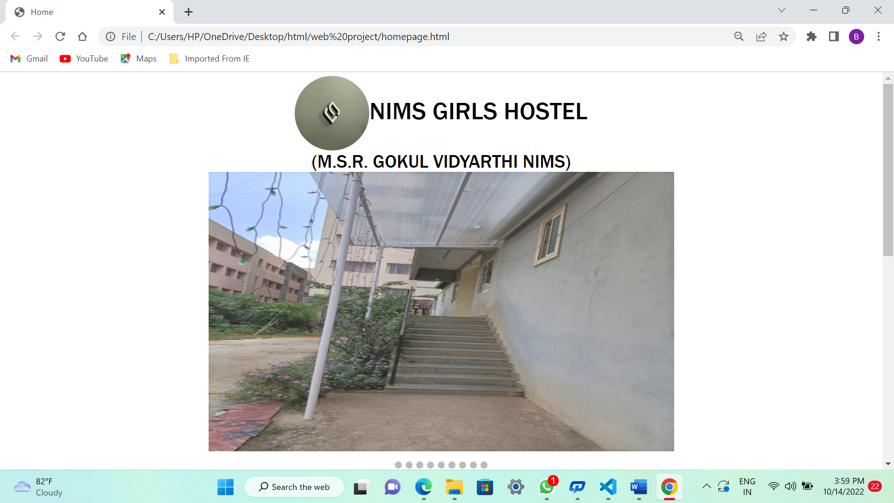

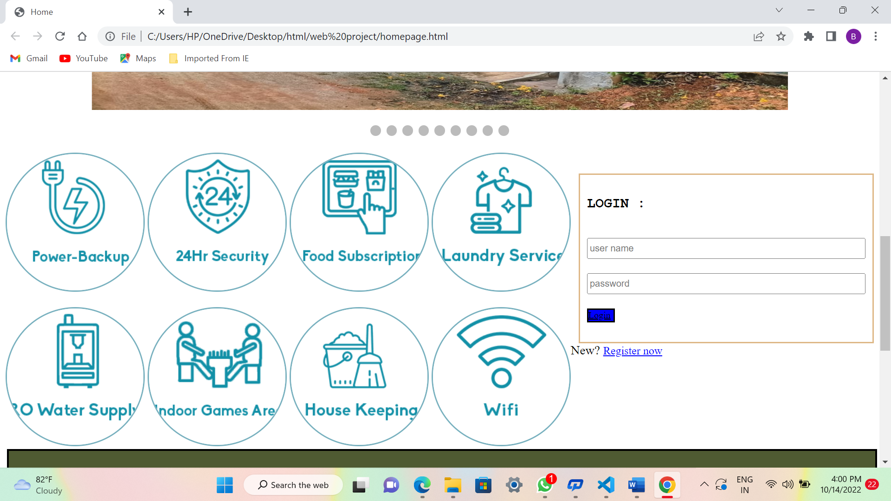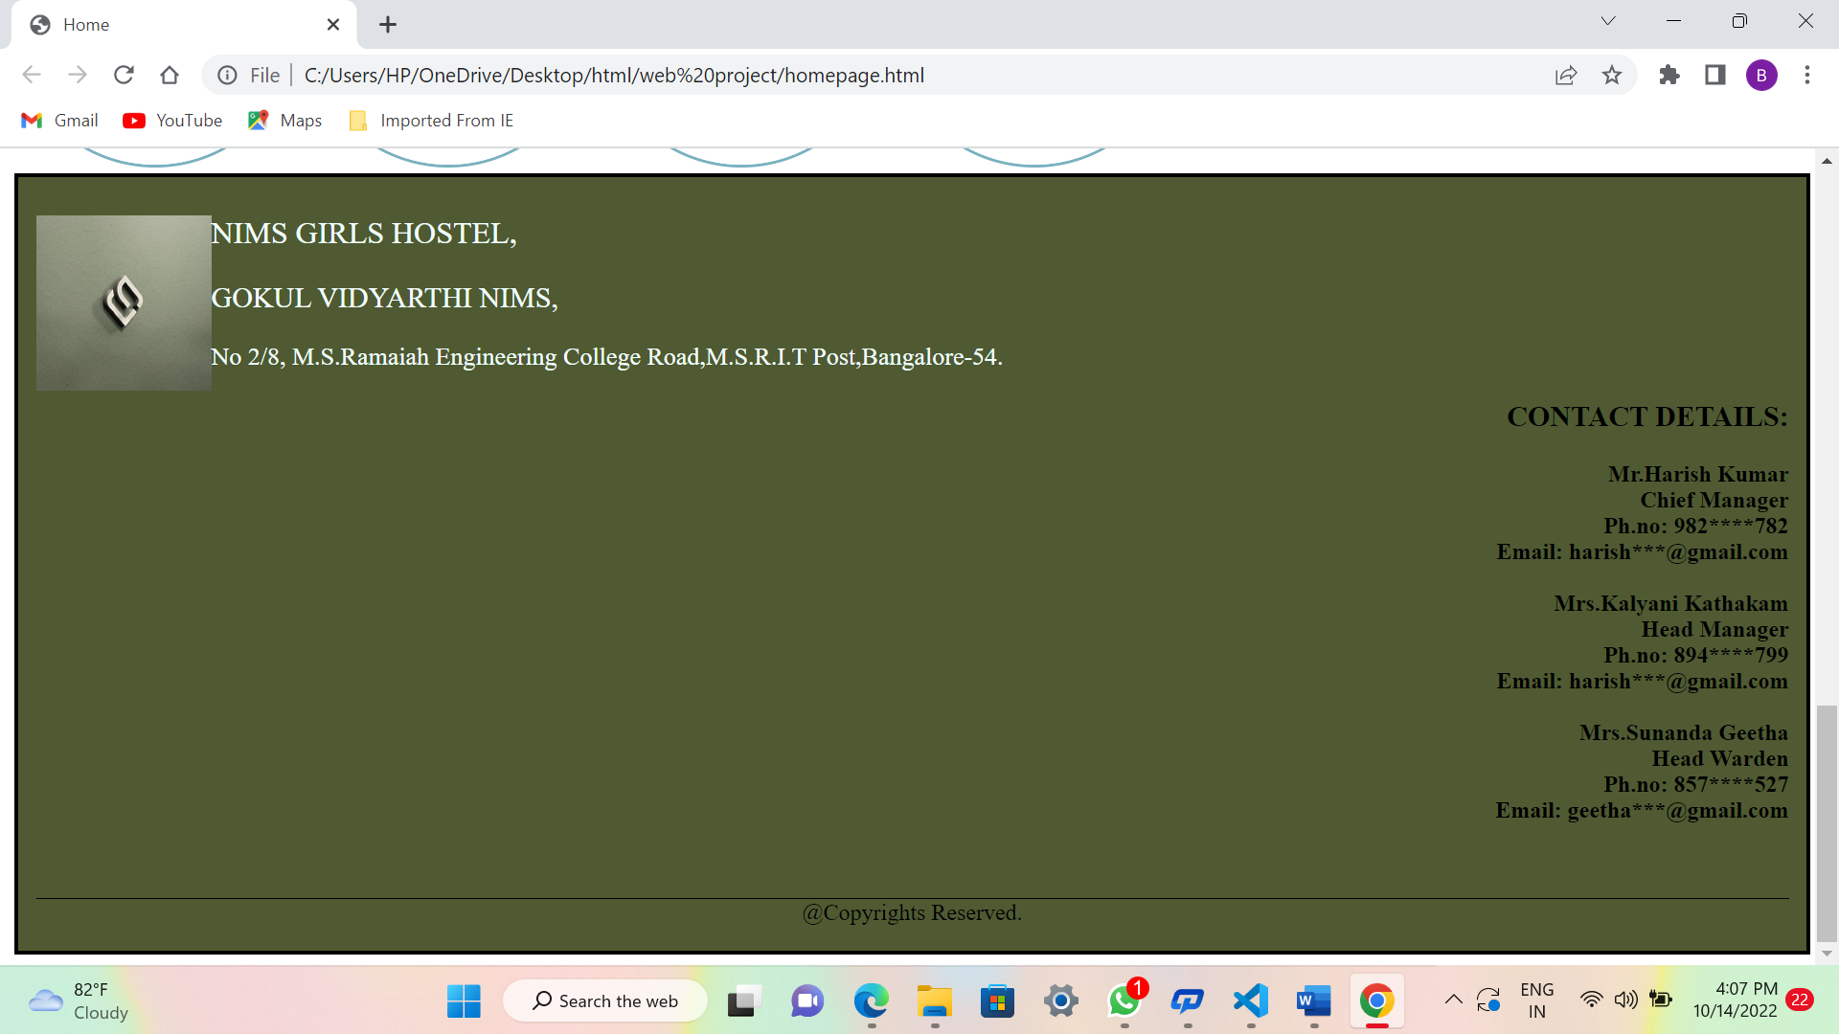

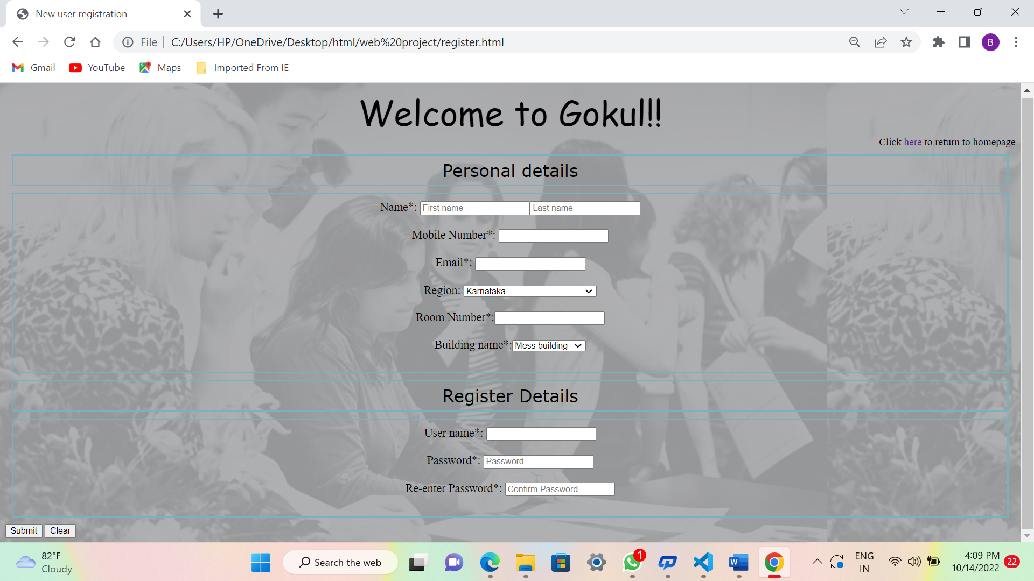

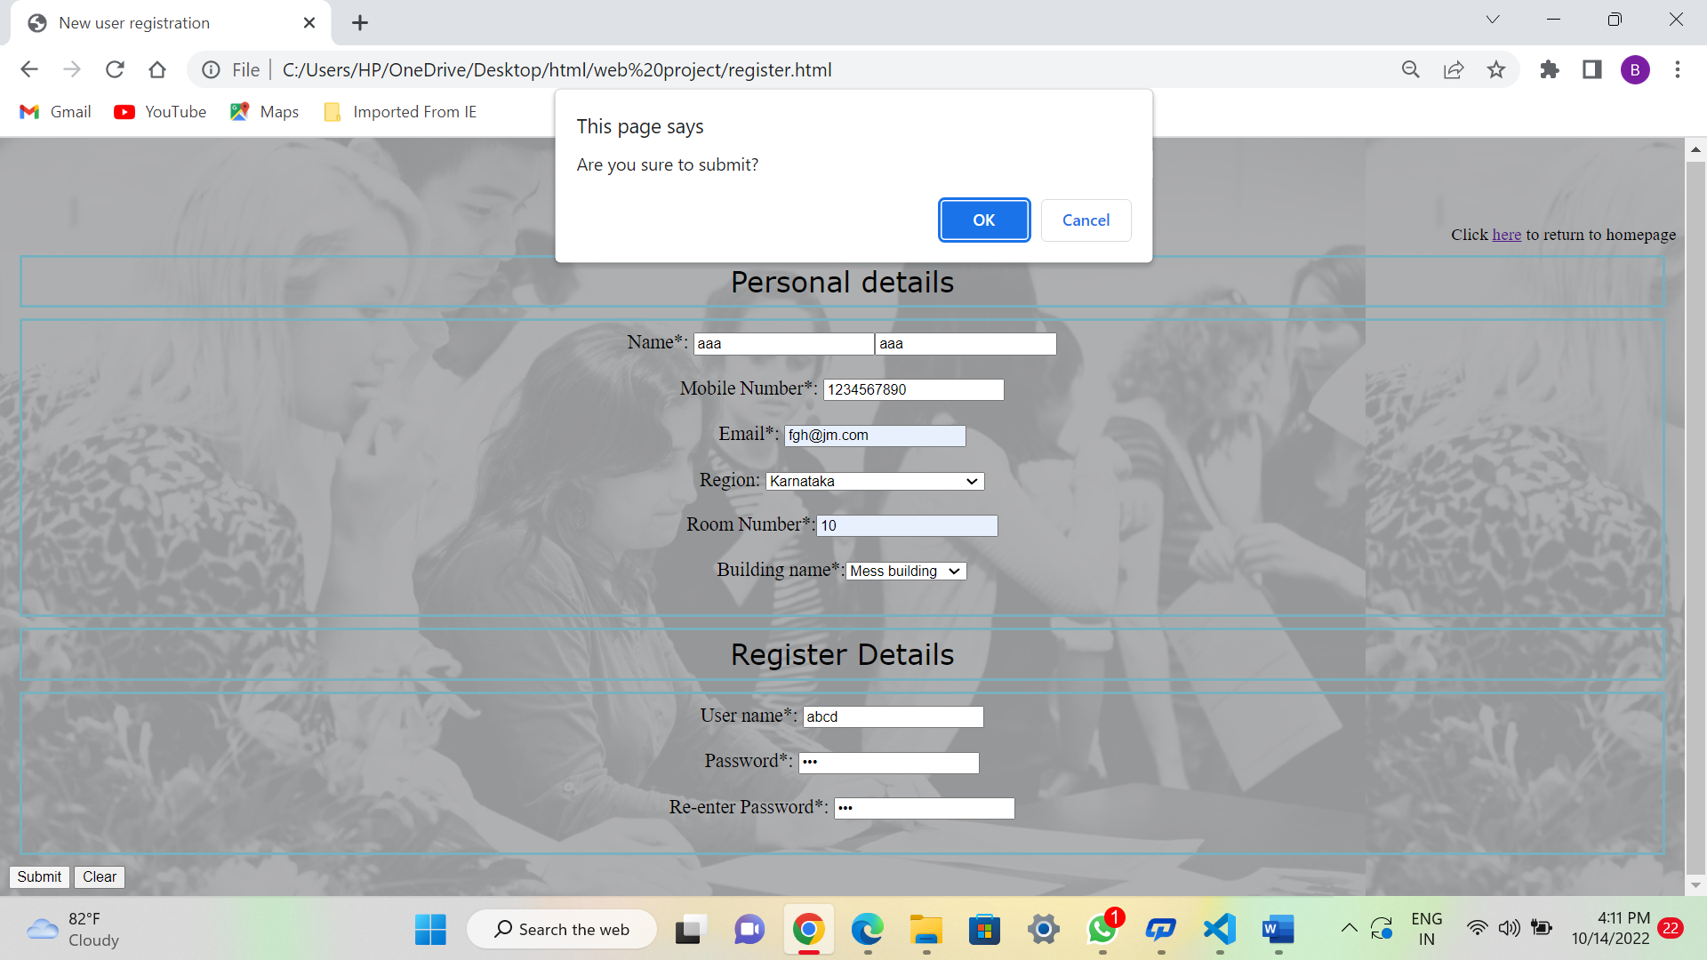

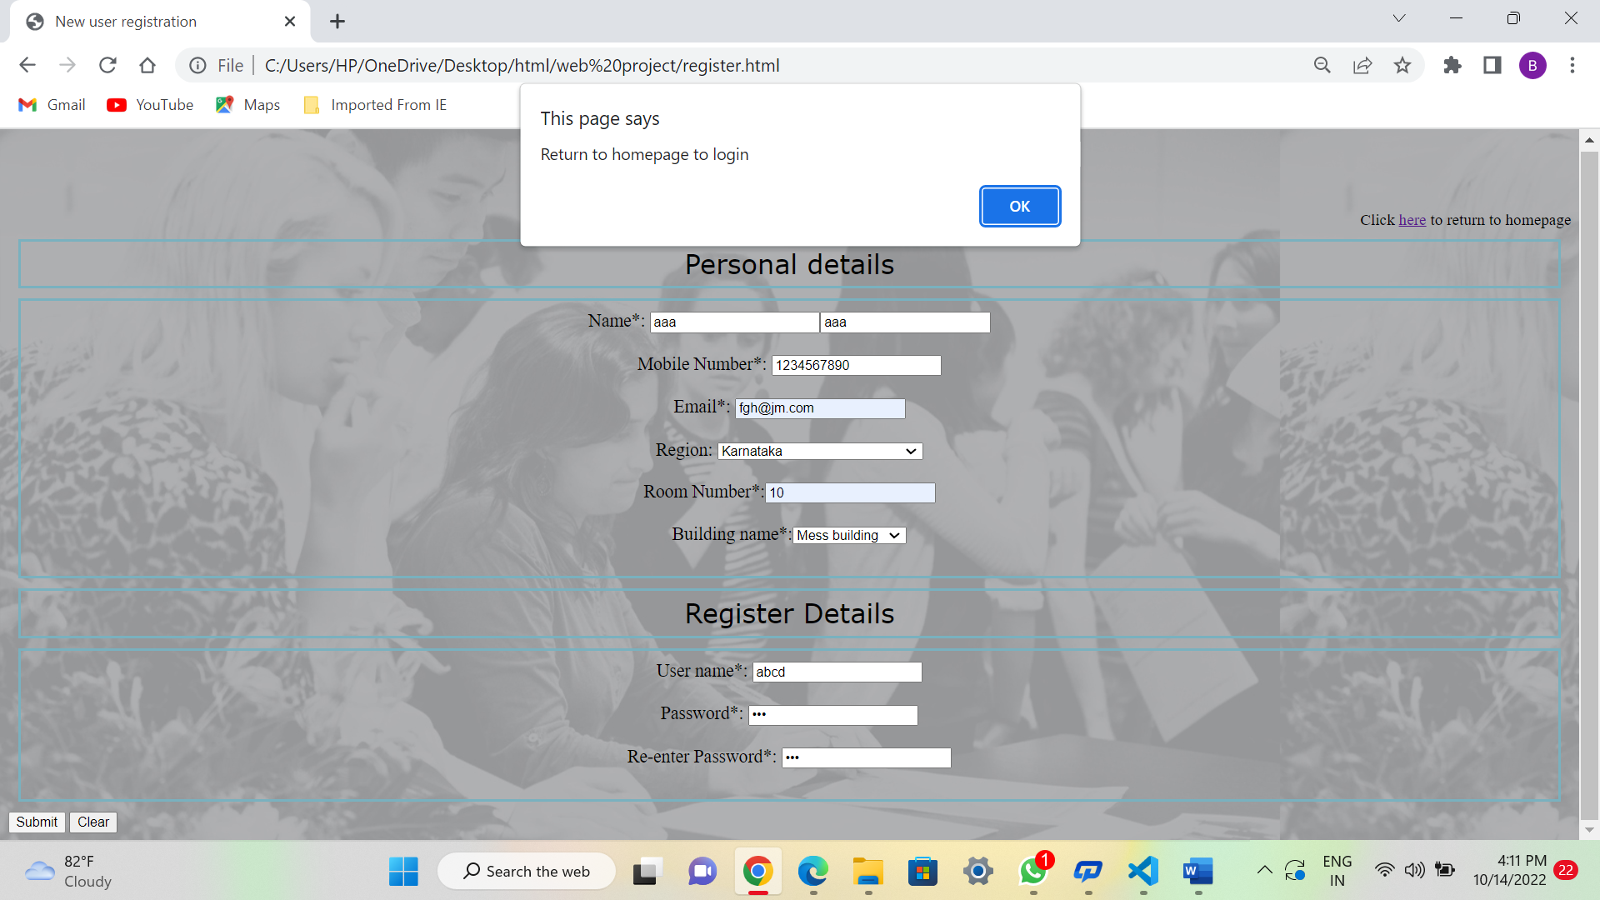

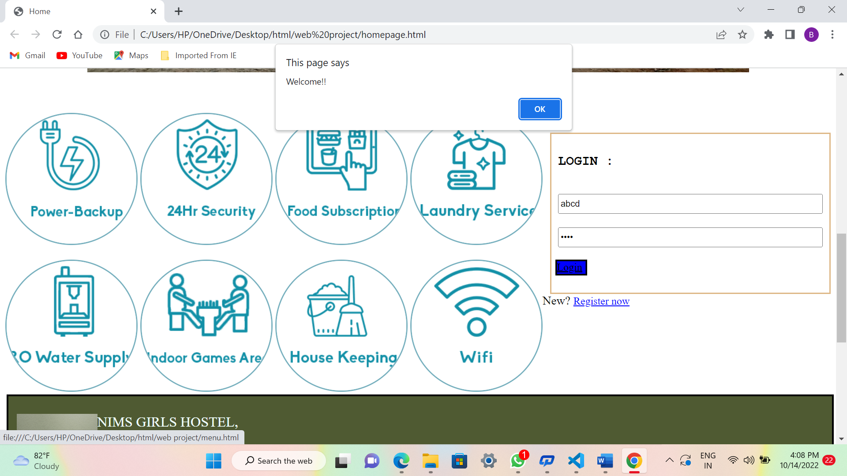

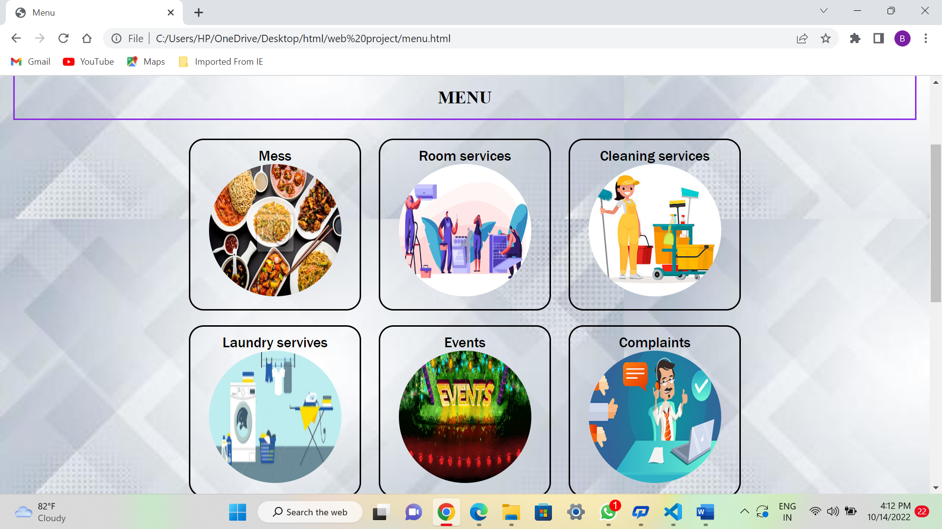

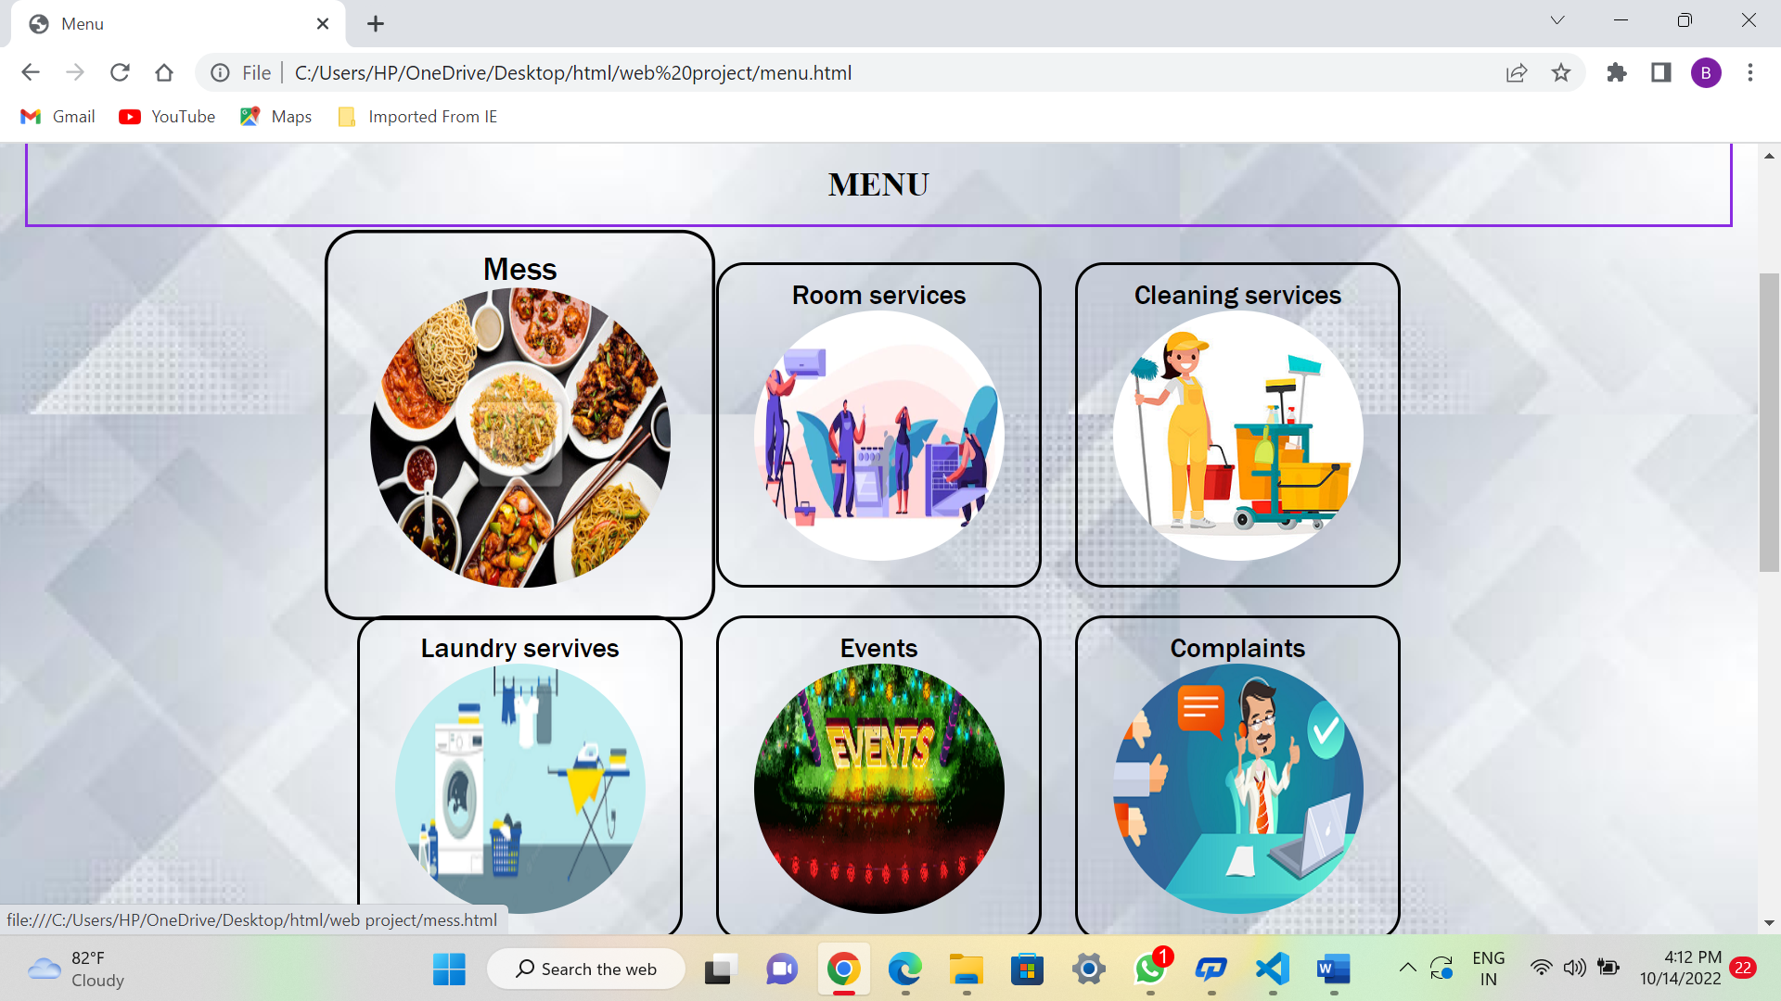

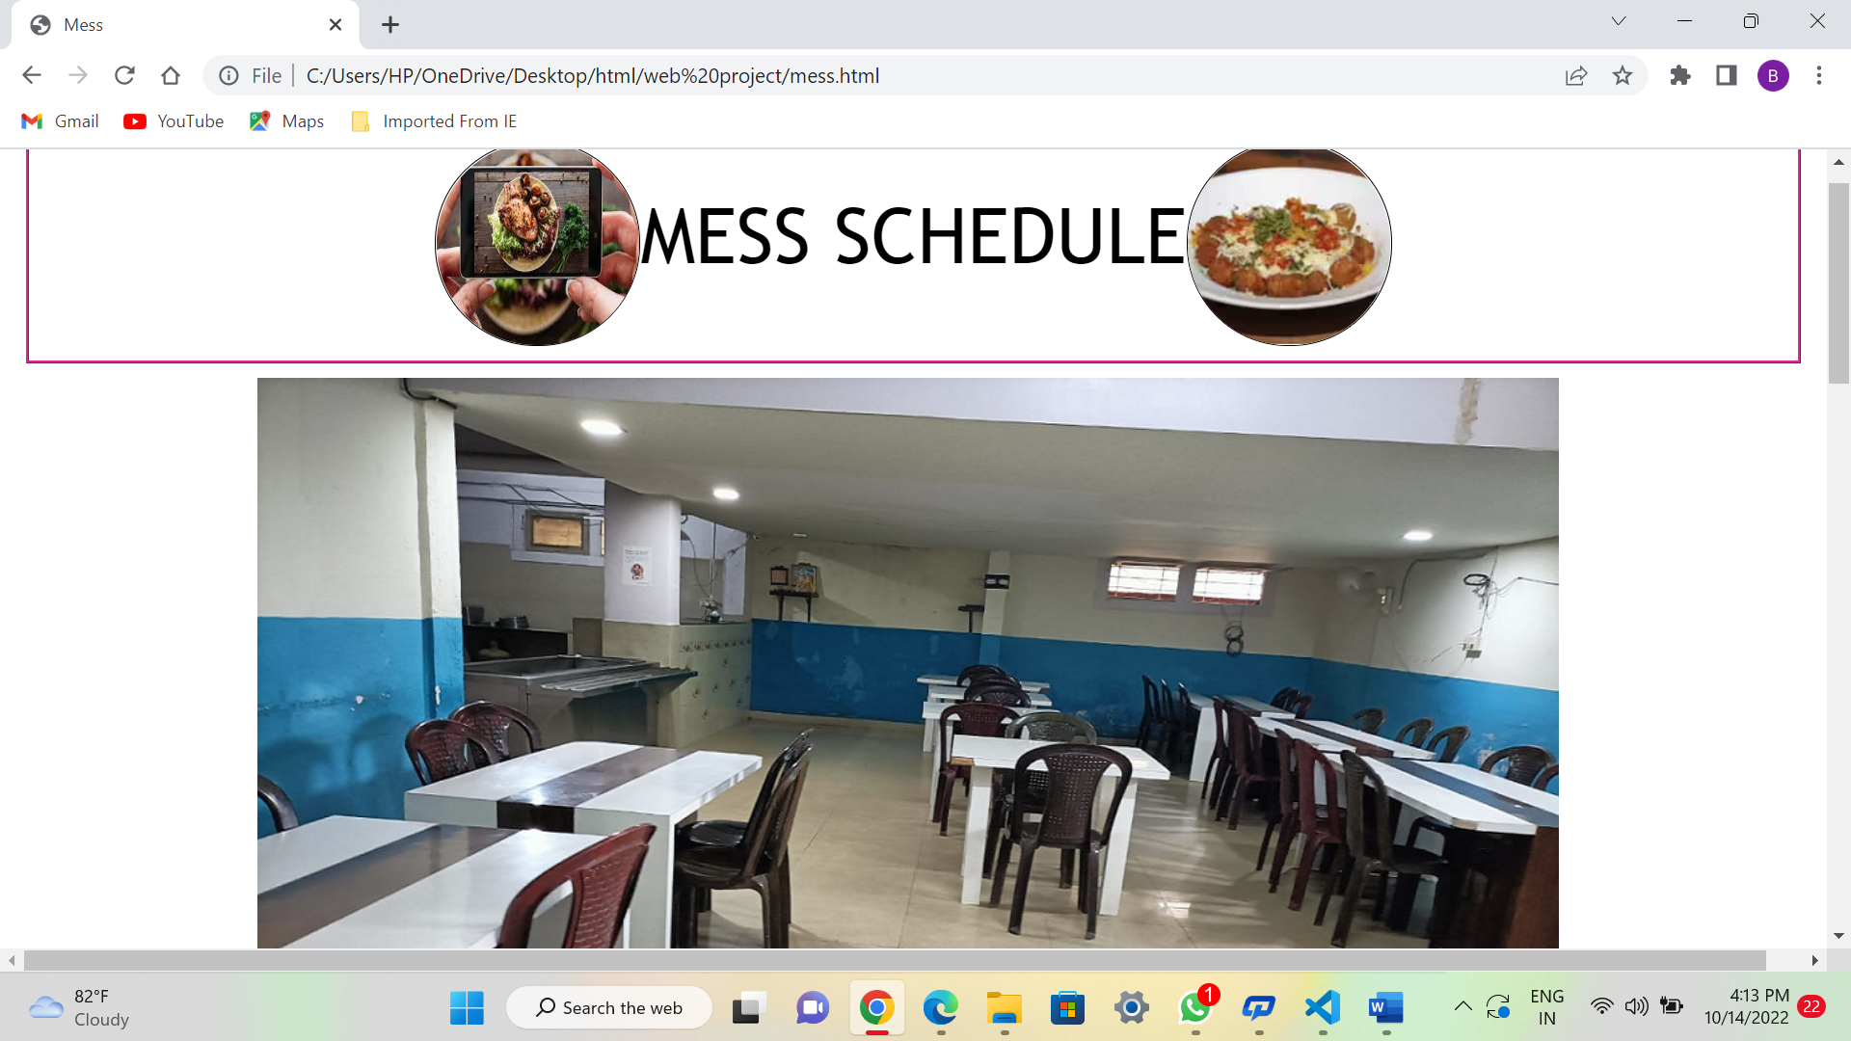

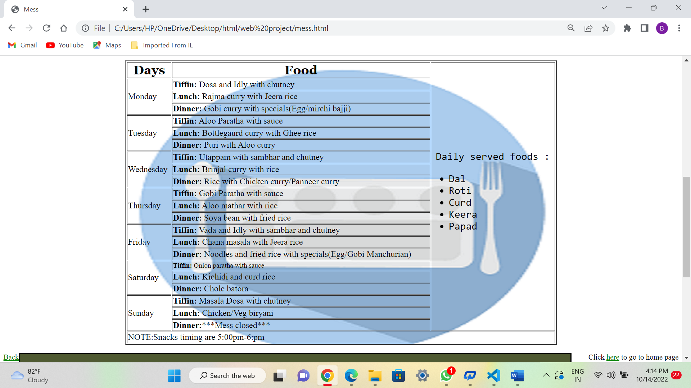

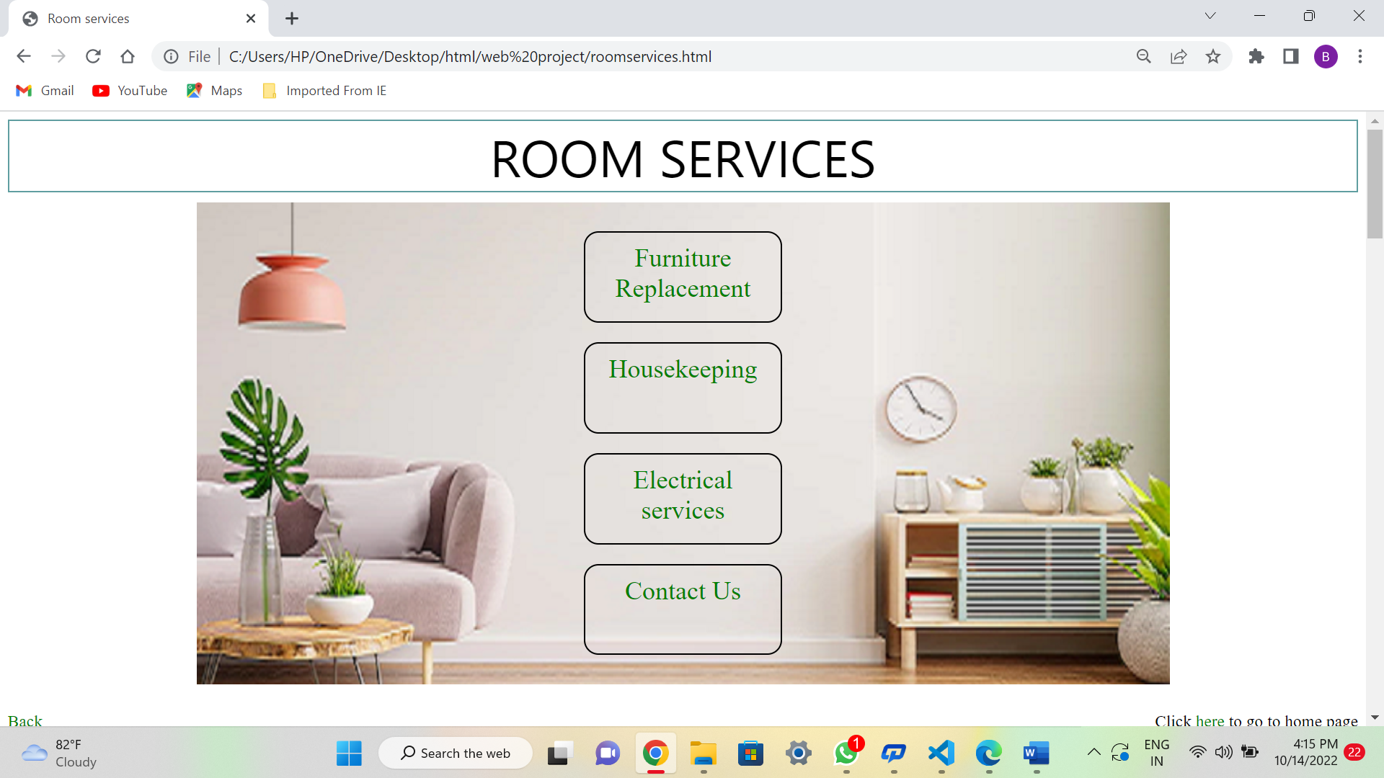

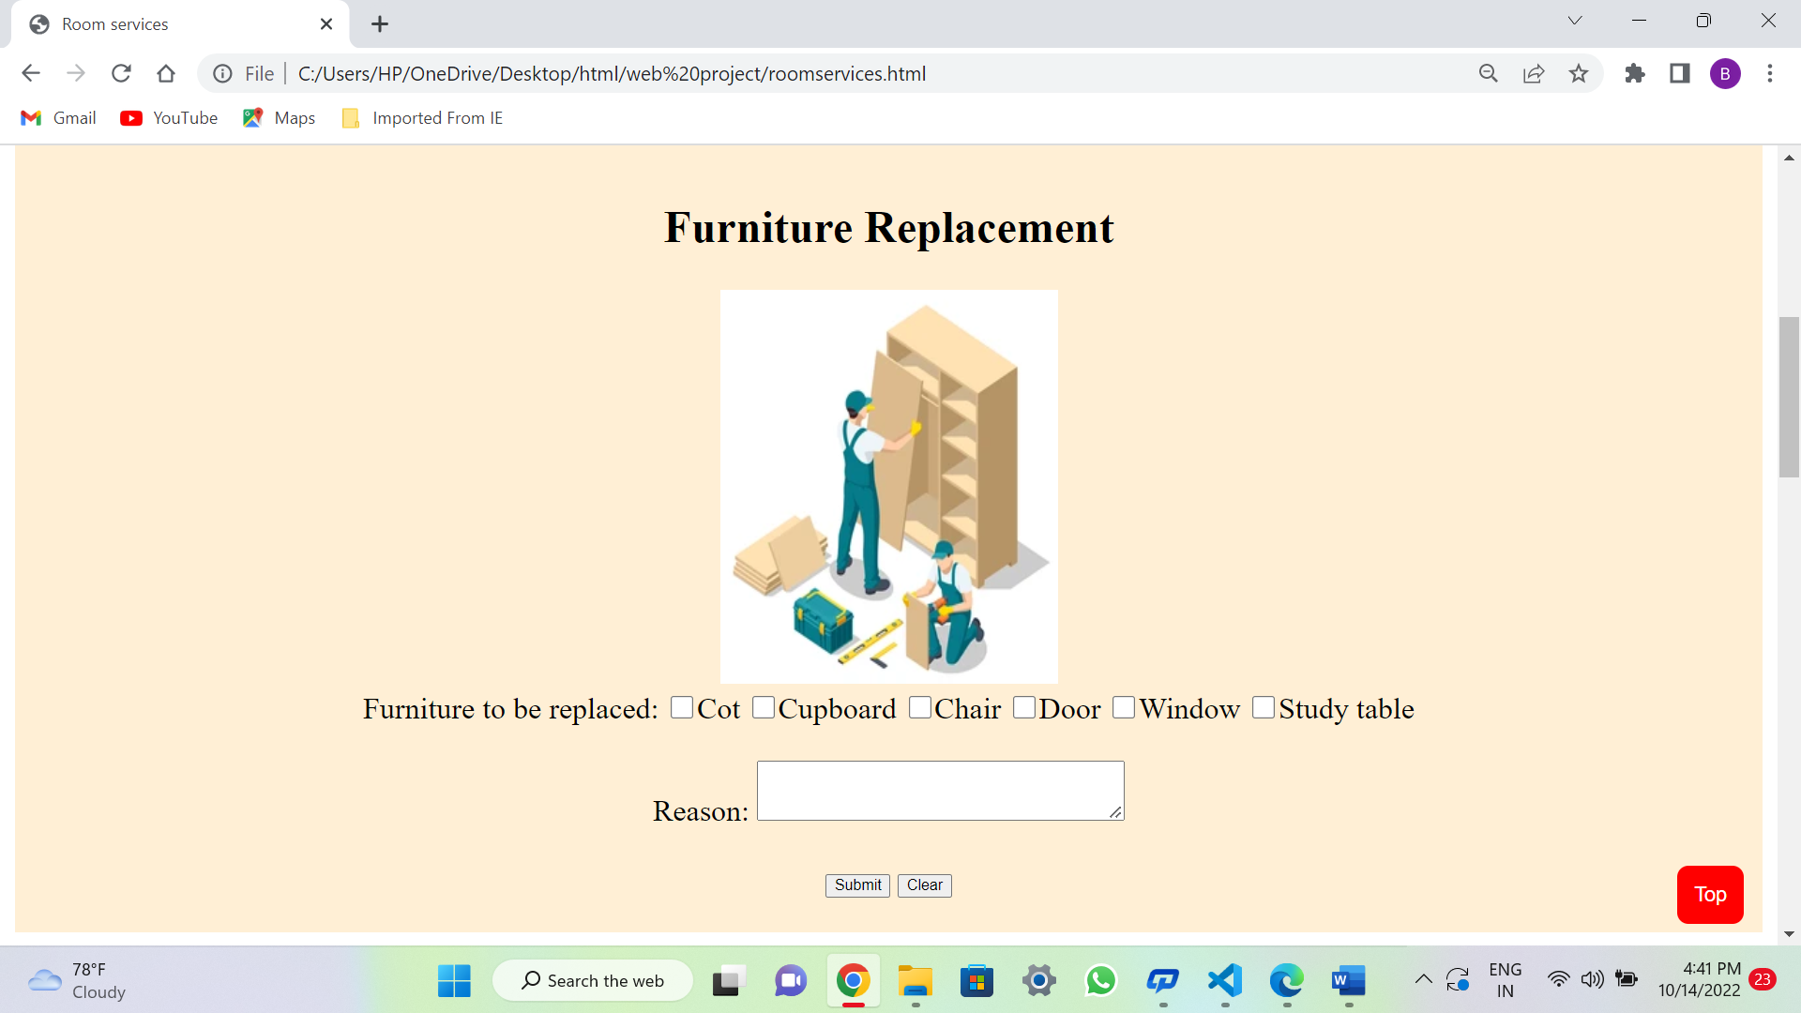

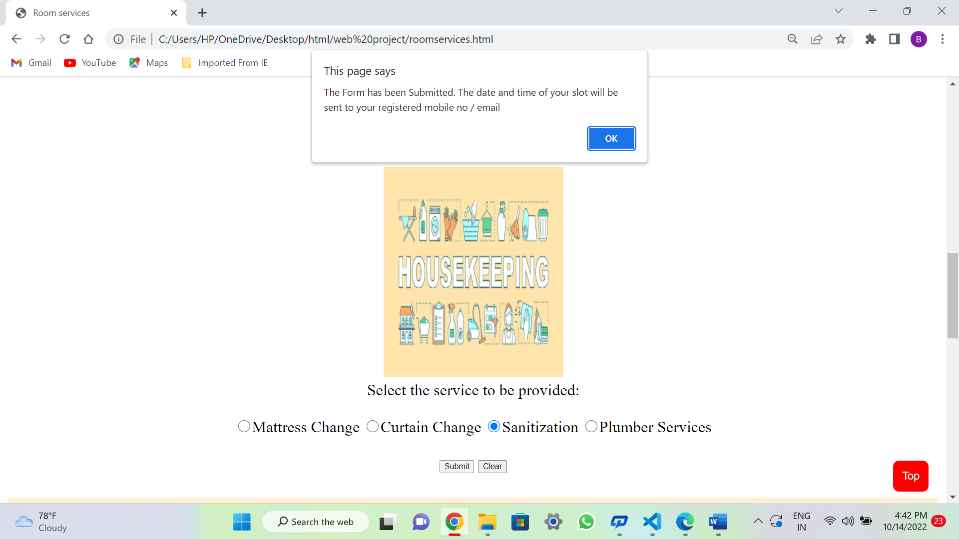

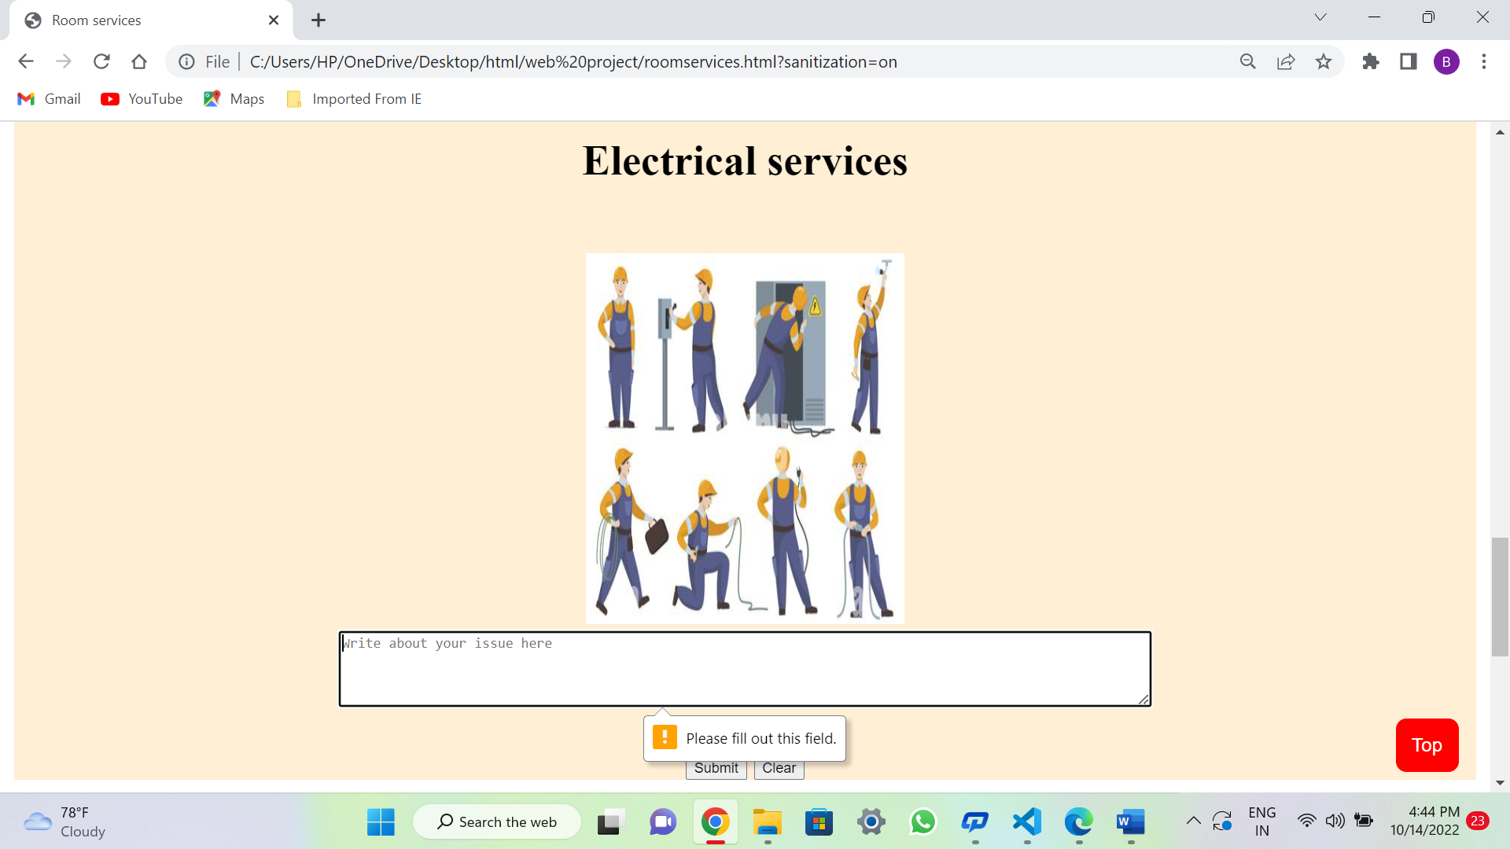

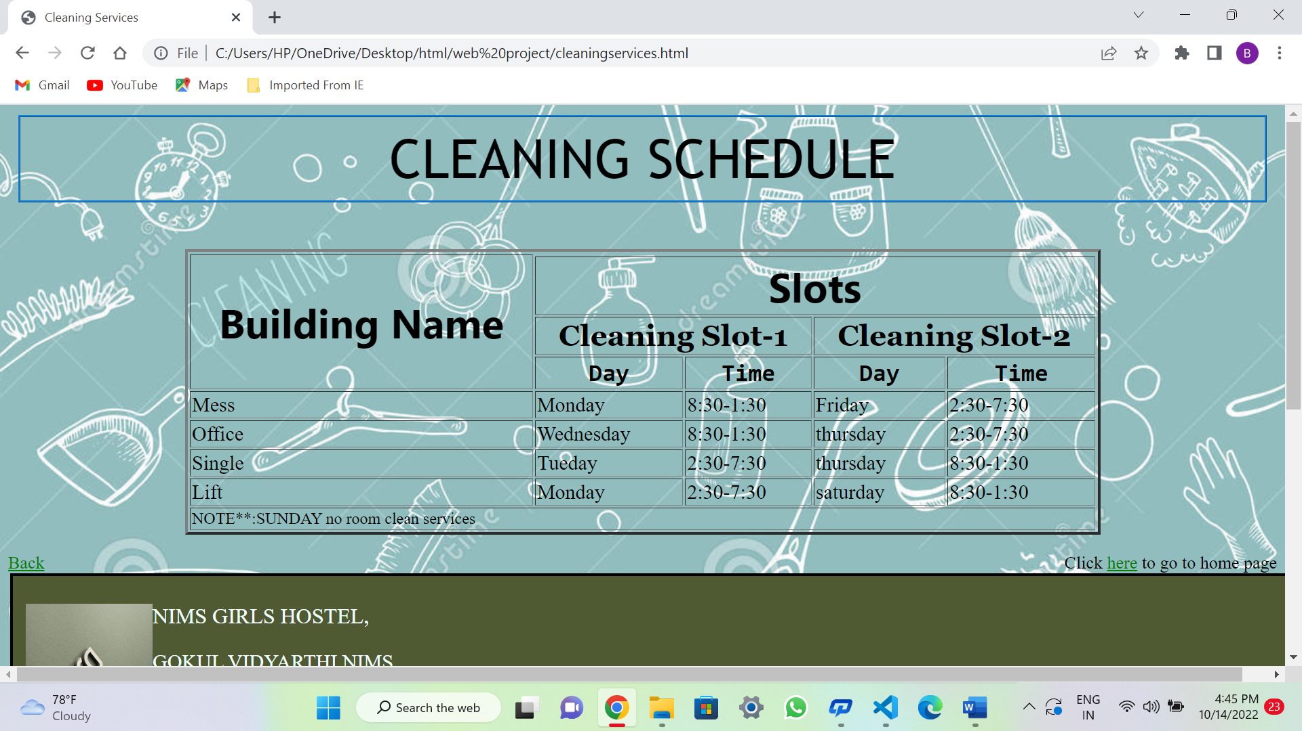

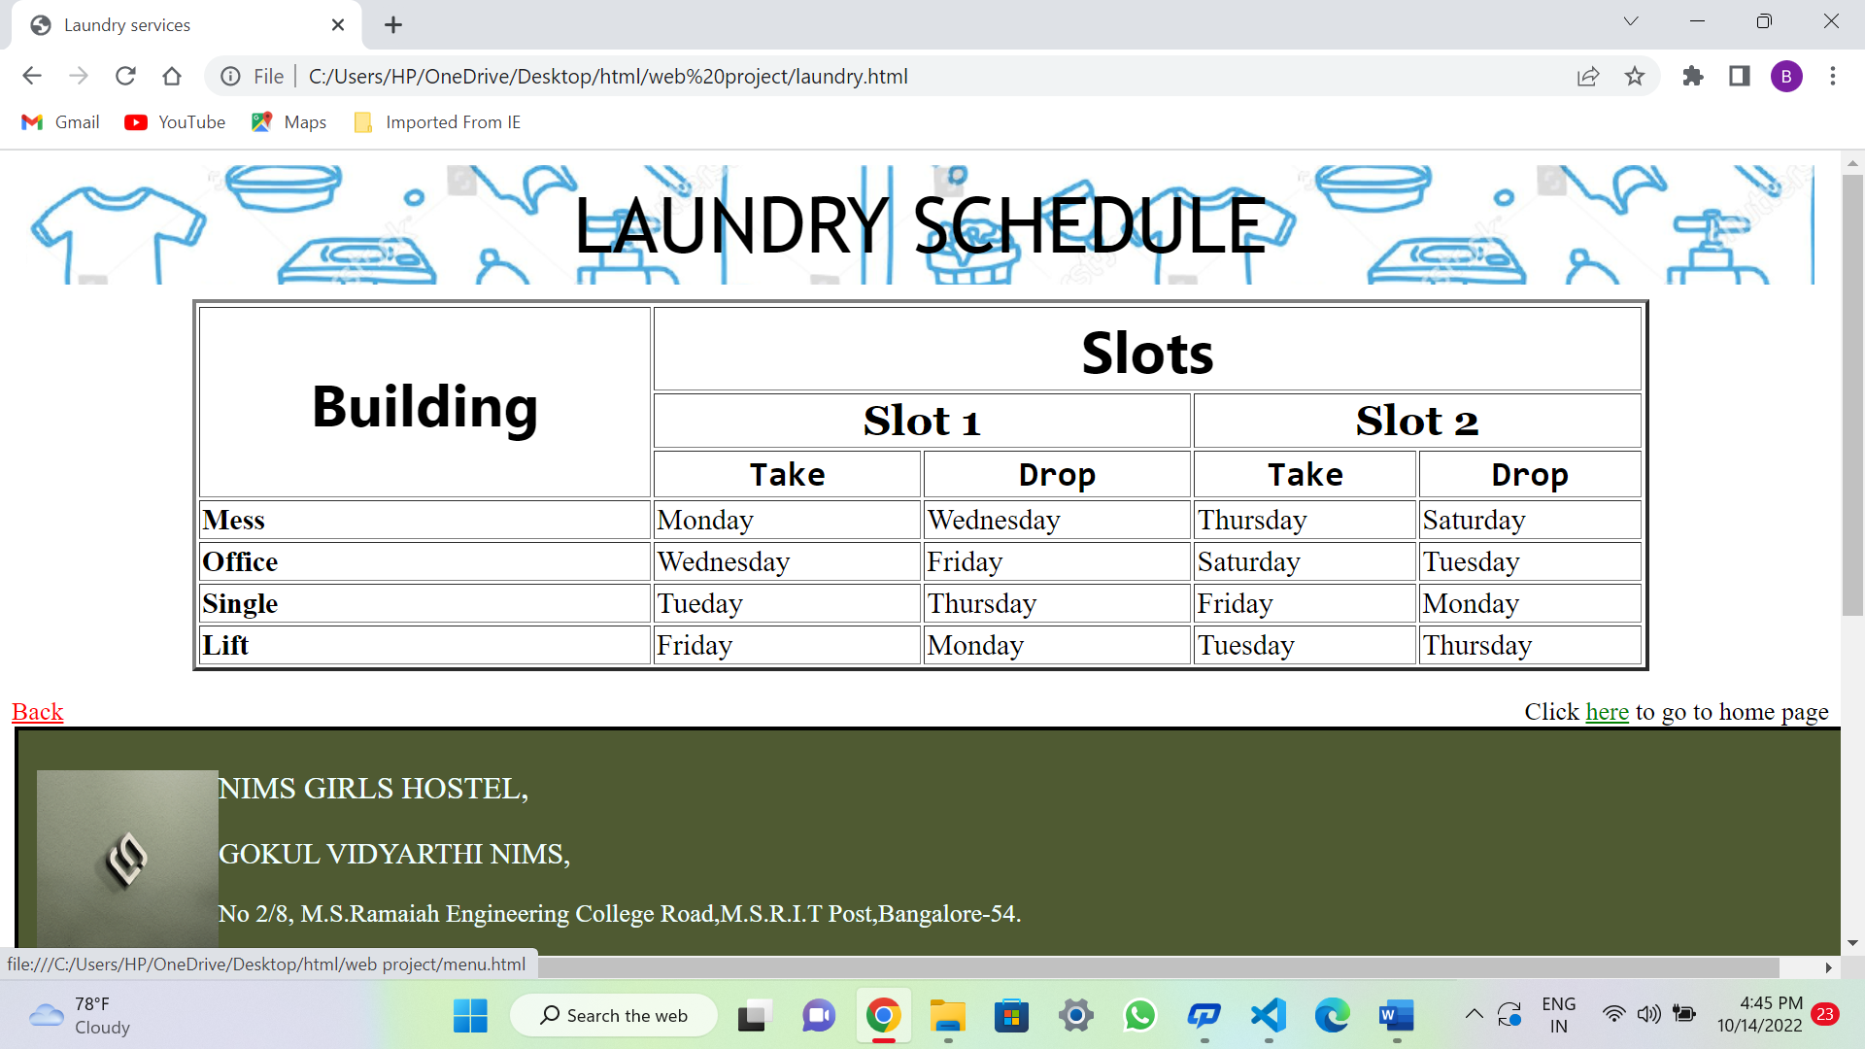

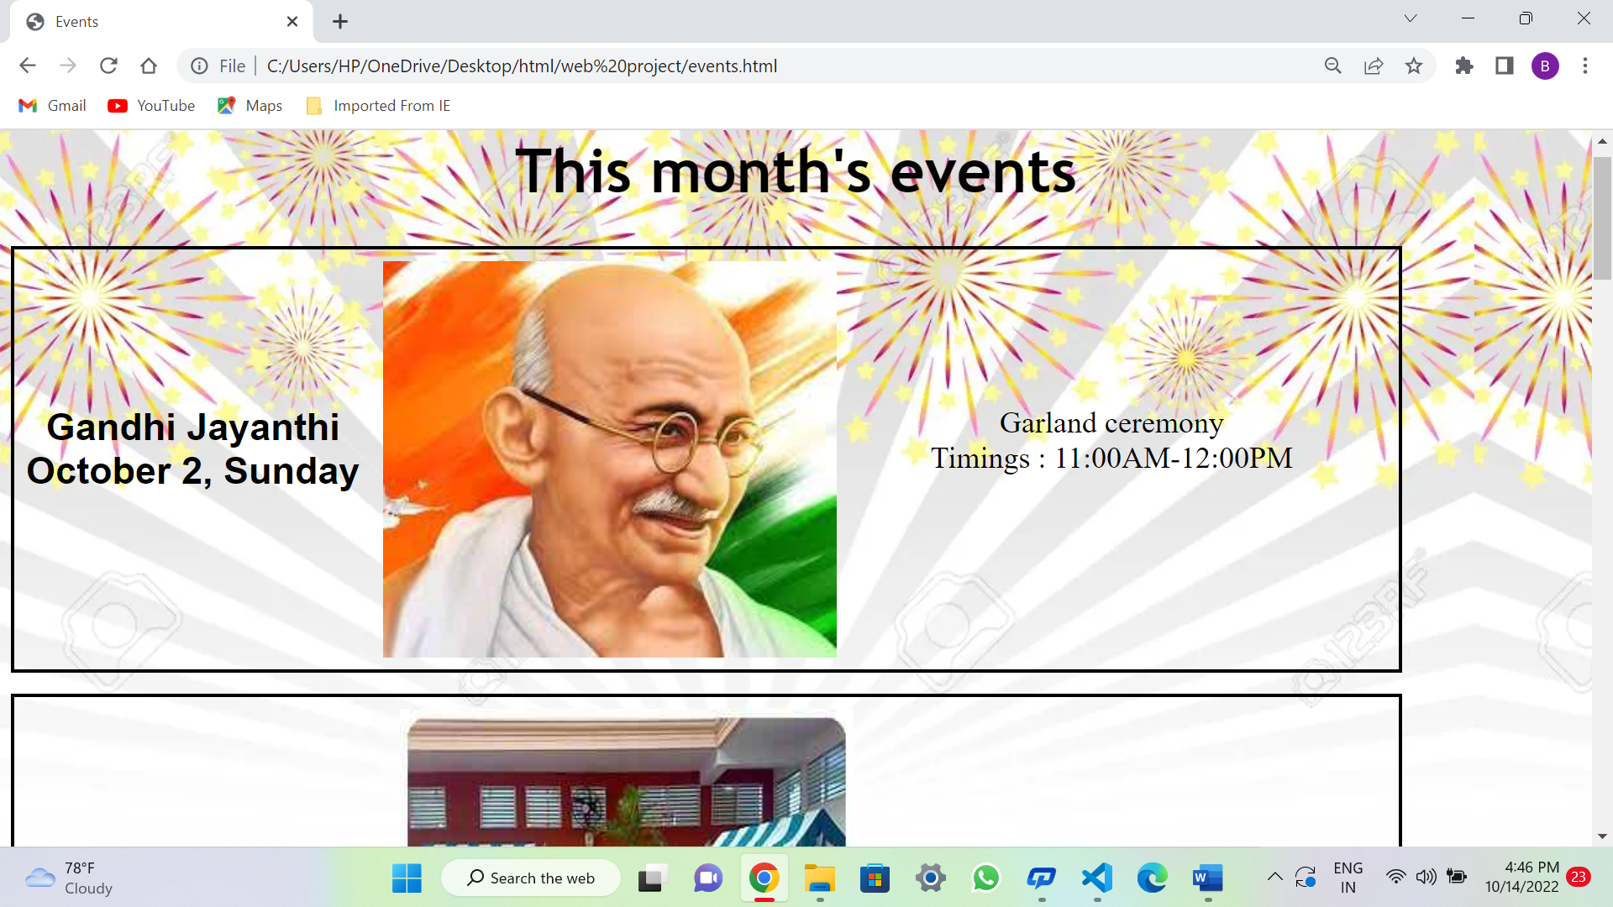

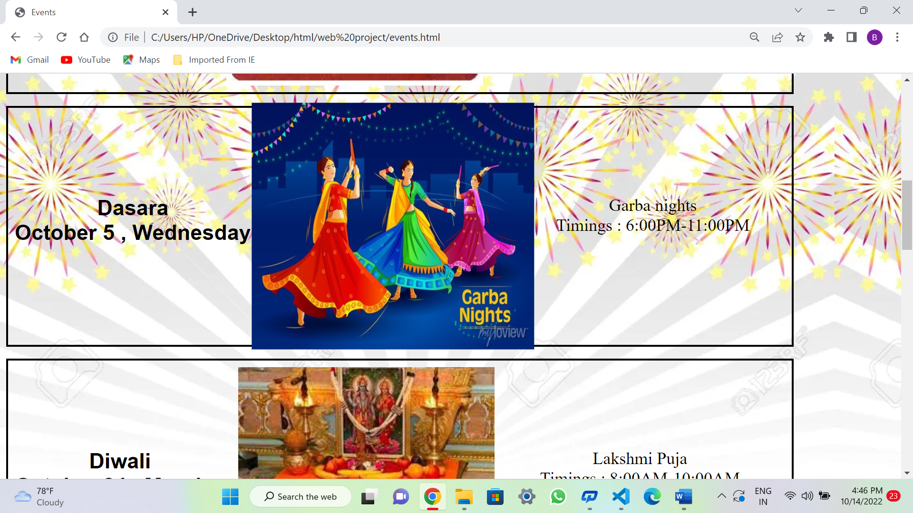

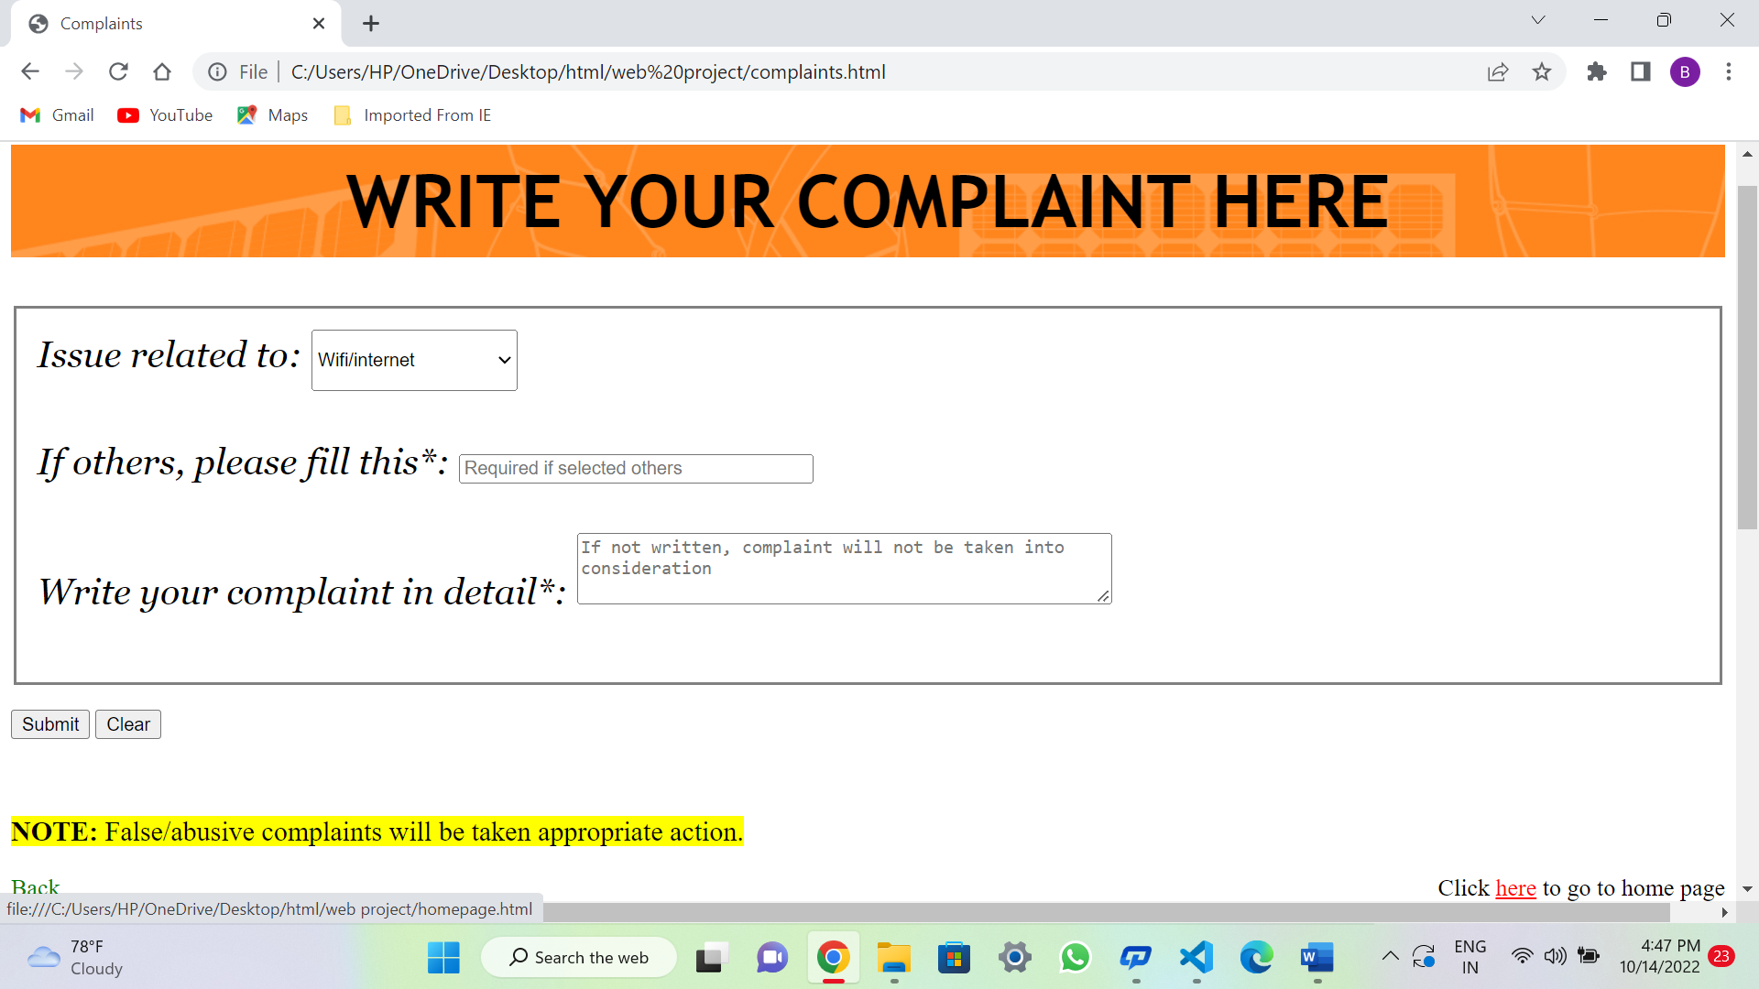

**CONCLUSION**

**-----------------------------------------------------------------------------------------**

The purpose and objective of the development of hostel services web page is achieved. By providing good graphical user interface, web page design is easy and in aesthetic form. I applied all the knowledge I gained from the skill lab of front end web development and tried to include everything I learned to make my web page a better one. I am able to use my problem-solving skills to troubleshoot errors when something did not work the way I planned. I successfully developed my own web page. I acknowledge my lecturers who have taught me and also my institute management for providing a platform to learn front end web development course.

*****